1. Applied for new DBS cert in order to enable update service application. Completed through HR

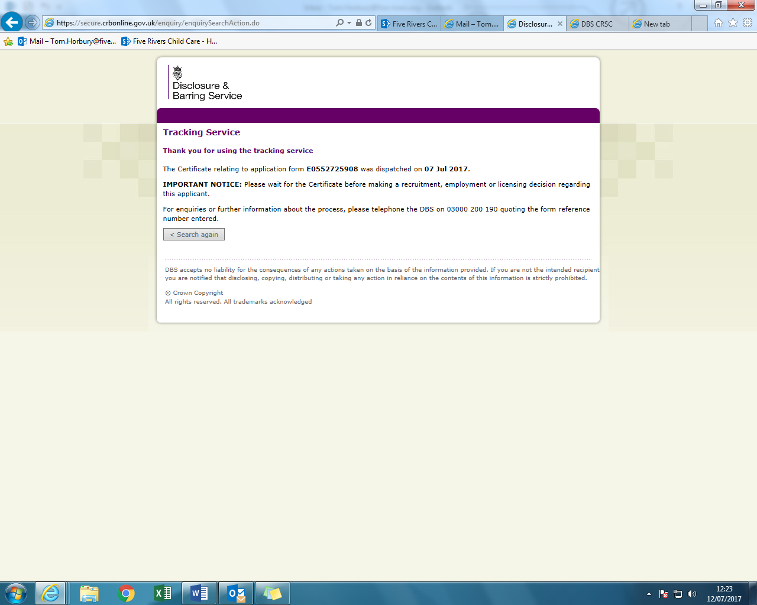

1. Complete Update service subscription. Googled its location and paid £13.00 to be recovered through expenses claim.

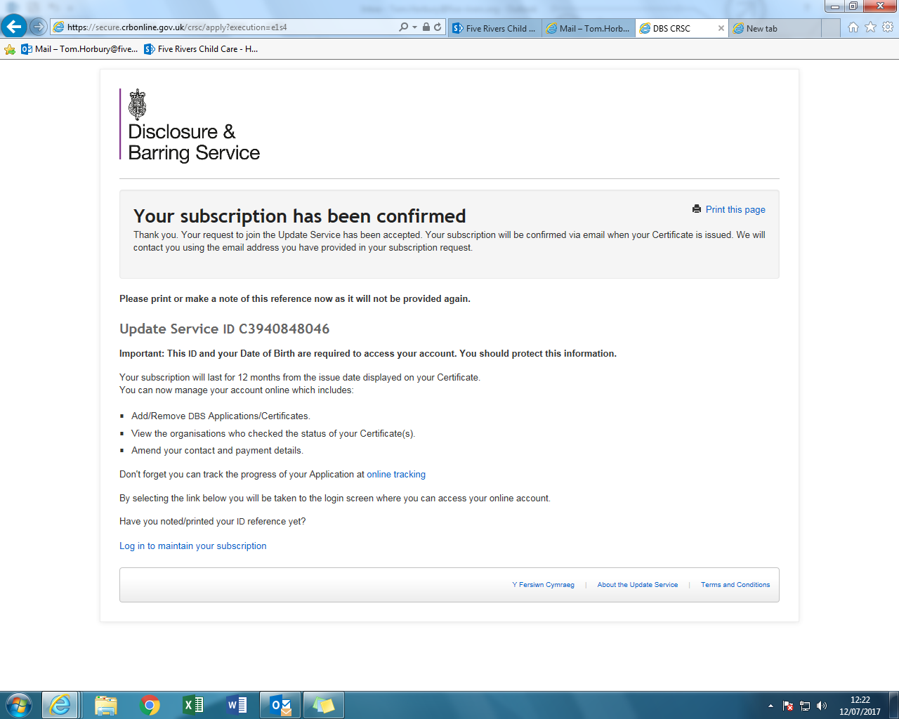

1. Complete Health declarations booklet. I completed Section A & B (completed 19.06.17), My General Practitioner completed section C (completed 29.06.17) and Section D is for Ofsted (Booklet is now attached to SC 2). The booklet cost was £30.00 made payable to the GP, also recoverable through an expenses claim.

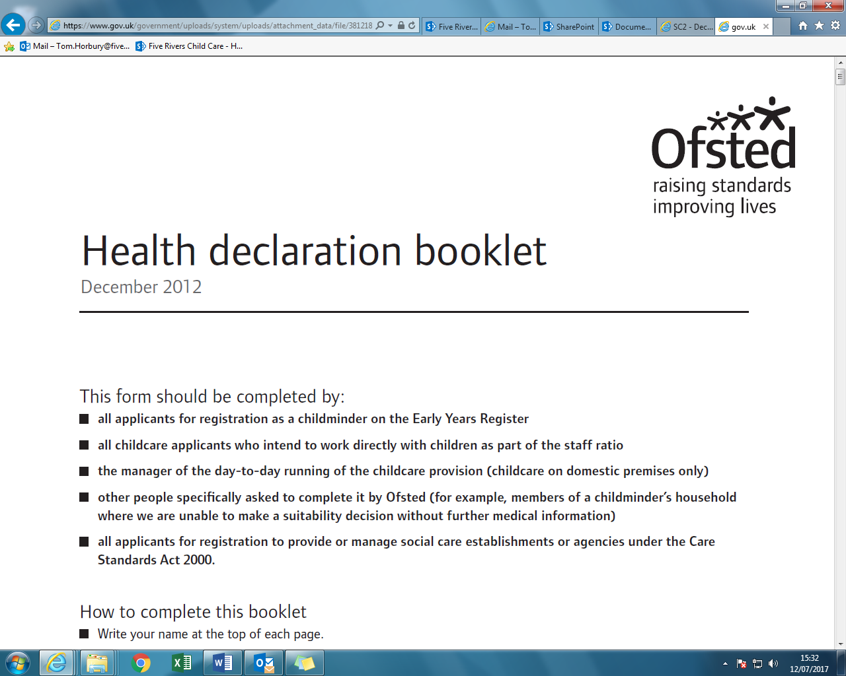

1. Complete SC2 application “Declarations and consent form for children's social care” (completed 14.07.2017). I have been informed that there will be no cost for the registration of a manager for a setting with under 3 rooms/placements and that a cost is relevant only for the registration of the home itself, not the manager.

